Volunteer application form  Please use type or dark ink | 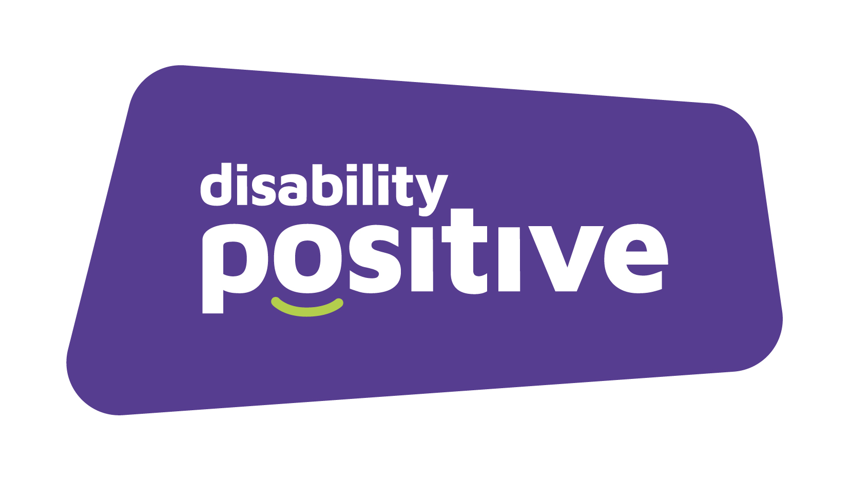
How did you hear about volunteering with us: please give details

Personal details

Title: | Name:
Telephone (home): | Telephone (mobile
Email Address:

Address:

Post Code:

Reasonable adjustments

We are an Equal Opportunities Employer and Disability Confident Leader. Applications are therefore particularly welcome from people with lived experience of disability and long-term conditions. We have a policy of interviewing people with experience of disability and long-term conditions who meet the essential criteria for the role.

Do you consider yourself to have lived experience of disability or long-term conditions?
Yes |  | No
We are committed to making reasonable adjustments where these would facilitate volunteering.

Relevant training or qualifications

Course title or area of training relevant to this role | Dates

Past work/volunteering experience

If you are able to, please give details of your current or previous work/volunteering experience
Continue on a separate sheet if necessary.

Employers/Organisation name | Dates from/to (month/year) | Role held and brief outline of duties | Reason for leaving

Supporting Information

Please tell us about any past experiences to demonstrate your skills and capabilities for volunteering.

Availability for Volunteering

Please provide brief details of your availability:

Will you be volunteering as part of a volunteering programme?
Yes |  | No
(for example: Millennium Volunteer, the Duke of Edinburgh Award, Job Centre Work Placements)

If yes, please provide brief details of which one and what would be required from Disability Positive:

Relations

Are you related to / or do you have any personal relationship with any employee of Disability Positive?
Yes |  | No

Criminal Convictions

Do you have any criminal convictions?
Yes |  | No
If yes, please give details on a separate sheet, this should exclude any spent convictions under Section 4 (2) of the Rehabilitation of Offenders Act 1974, unless the role for which you are applying involves working with vulnerable children or adults, directly or indirectly.

As this role is one of those to which the provisions of the above Act in relation to spent convictions, do not apply, cautions, bindovers, pending prosecutions, spent and unspent convictions must be declared.

Should you identify that you have a criminal conviction, this will be discussed in confidence at interview. However, you should note that only convictions that are relevant to the role in question will be taken into account.

Enhanced Disclosure and Barring Scheme

(only complete this section if it has been identified as required as part of the role)

Are you aware of any police enquires undertaken following allegations made against you, which may have a bearing on your suitability for this role?
Yes |  | No

References

Please provide contact details for two referees covering the last 2 years (work or volunteer reference where possible) .

Referee 1 |  | Referee 2
Name: |  | Name:
Job Title: |  | Job Title:
Organisation: |  | Organisation:
Address: |  | Address:
Postcode: |  | Postcode:
Phone No: |  | Phone No:
Email: |  | Email:

If you are not able to provide references please state why:

Declaration

In accordance with the Data Protection Act 1998, and the General Data Protection Regulations 2018, the information provided on this form will be used as part of the recruitment and selection process and may be disclosed to those who need to see it. It will also form the basis of the confidential personnel record of successful applicants. In the case of unsuccessful applicants, the application form will be destroyed after 6 months, in line with our HR Privacy notice.
I confirm that I have read and understood the privacy notice, and that I do not object to the information collected being used for anonymous statistical reporting, to assist Disability Positive in equal opportunities monitoring.
I confirm that the information provided in this application form is accurate to the best of my knowledge. I understand that any false misleading statements could place any subsequent volunteering in jeopardy. I understand that any volunteering agreement entered into is subject to satisfactory references and that Disability Positive has a right to validate any of the information provided.

Signed: Dated:

Please return this form to volunteer@disabilitypositive.org

