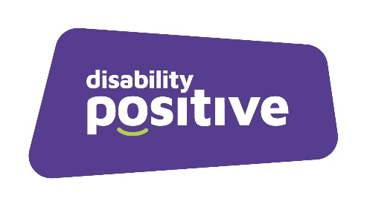

Recruitment Monitoring Form

Please complete this form to enable Disability Positive to compare the success rates of relevant groups at both the short-listing and appointment stages. The information is used for anonymous statistical reporting, to assist Disability Positive in equal opportunities monitoring and for no other reason. This form will be treated in confidence.

Role applied for:

Gender

Male Female

Disability

Do you consider yourself to have a disability or long-term condition?
Yes |  | No

Age Range

16-25 26-35 36-45 46-55 56-65 66 and over

Employment Status

Are you currently:
In employment | Self-employed
On a Career Break | Unemployed
Retired

Please return this form separately to hr@disabilitypositive.org

