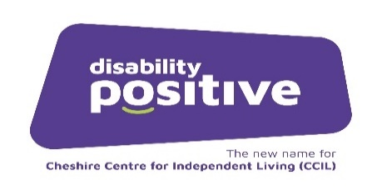



**CHC Advocacy Referral Form Cheshire West & Cheshire & Cheshire East**

In order to comply with data protection legislation please send completed referral forms electronically via egress to: [advocacy@ageukcheshire.org.uk](mailto:advocacy@ageukcheshire.org.uk). If you do not have to access to egress please send them to the same email address but password protected. Please ensure the password is sent separately.

**Contact details:**

Cheshire Advocacy Hub

Castle Community Centre

Barbers Lane

Northwich

CW8 1DT

**Telephone number: 03333 66 00 27**

Upon receipt of the referral form the Cheshire Advocacy Hub will allocate this referral to an Advocate from Age UK Cheshire or Disability Positive.

|  |  |  |  |  |  |
| --- | --- | --- | --- | --- | --- |
| **Date of Referral** |  | | | | |
| **Referrer Details**  Name, designation, organisation, telephone number & email |  | | | | |
| **Client Details**  Name, Address (if this is temporary address please advise of permanent address), telephone number, date of birth |  | | | | |
| **Carer Details (if applicable)**  Include name, address, contact number & relationship to client |  | | | | |
| **G.P. Details**  Name and address of G.P. practice |  | | | | |
| **Communication**  How does the client prefer to communicate |  | | | | |
| **Risk**  Is there any information the advocate needs in order to keep the person and/or the Advocate safe? (e.g. health or behaviour issues?)  Are there any risk factors in home(e.g. pets, accessibility, smoker) |  | | | | |
| **Equality & Diversity Information** | **Please complete or tick relevant box** | | | | |
| **Gender** |  | Not Known |  | Prefer Not To Say |  |
| **Ethnicity** |  | Not Known |  | Prefer Not To Say |  |
| **Any Disability Yes/No** |  | Not Known |  | Prefer Not To Say |  |
| **Main Disability if Yes to above** |  | Not Known |  | Prefer Not To Say |  |
| **Sexual Orientation** |  | Not Known |  | Prefer Not To Say |  |
| **Religion** |  | Not Known |  | Prefer Not To Say |  |

Have reasons for this referral been discussed with the client (and/or family, if appropriate)?

|  |  |  |  |
| --- | --- | --- | --- |
| Yes |  | No |  |

|  |  |  |  |
| --- | --- | --- | --- |
| Yes |  | No |  |

Is the client (and/or family) aware of potential outcomes of a

successful CHC application

|  |  |  |  |
| --- | --- | --- | --- |
| Yes |  | No |  |

|  |  |  |  |
| --- | --- | --- | --- |
| Yes |  | No |  |

Has the Eligibility Checklist been completed?

Has the DST been completed?

|  |  |  |  |
| --- | --- | --- | --- |
| Yes |  | No |  |

Is there a current package of care in place?

If yes, who is this funded by and what is the amount?

|  |
| --- |
|  |

**Any other relevant information including the clients desired outcome:**

|  |  |
| --- | --- |
| **Consent to referral?** | **ü** |
| Have you discussed this referral with the person being referred? |  |
| Has the person agreed to this referral being made? |  |

**Consent**

I have read and understood how you will use and process my data for this service and I have informed any relevant third-parties of the information I provide to you about them, in line with the [privacy notice](https://www.ageuk.org.uk/cheshire/privacy-policy/)

Signed Date

Thank you

Please return your completed form to [**advocacy@ageukcheshire.org.uk**](mailto:advocacy@ageukcheshire.org.uk)