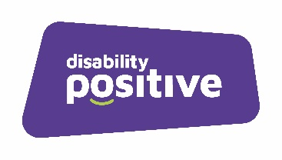
MANDATORY ONLINE TRAINING
Please tick required course
PA
Name…………………………………Email…………………..………………………………..
Employer
Name…………………..….…………Email…..…….………………………………………….
P A Training
Equality & Diversity
Infection Control & Awareness
MCA & DOLS Awareness
Moving & Handling People Awareness
Safeguarding Adults or Children – Level 1-3
GDPR Awareness
Emergency First Aid awareness
Fire Safety Awareness
Food Safety – Level 2
Health & Safety Awareness

Employer Training
Care Planning
Information Governance Awareness
Conflict Management
DBS Certificate
Interview Skills
Managing People
Safer Recruitment
Staff Appraisal Skills
Fire Safety Awareness
RIDDOR Awareness
Risk Assessment Awareness

There are additional on-line courses available. If you wish to access any of the courses below, please ensure they specify to your requirements in your supporting role.
Additional Training
Allergen Awareness
Autism Awareness
Disability Awareness
Epilepsy Awareness
Diabetes Awareness
Learning Disabilities Awareness
Mental Health Awareness
Self-harm awareness
Drugs and Alcohol Awareness
Dementia Awareness
Substance misuse awareness
Fall Prevention Awareness
Loss & Bereavement
MCA & DOLS Awareness
Medication Awareness
Medication Advanced
Catheterisation Awareness
Diet & Nutrition Awareness
Dignity, Privacy and Respect
Oral Health Awareness
Pressure sore awareness
Sepsis awareness
Palliative End of Life care
Person Centred care awareness
Communication and Record Keeping

Tele: 01606 331853

Email to: learning@disabilitypositive.org

