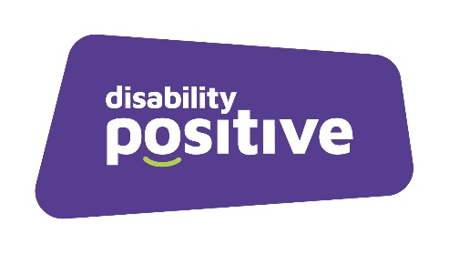

Recruitment Monitoring Form

Disability Positive is committed to promoting equality and diversity and promoting a culture that actively values difference and recognises that people from different backgrounds and experiences can bring valuable insights to the workplace and enhance the way we work.

Therefore, completing this form enables us to compare the success rates at both the short-listing and appointment stages, in line with our Equality and Diversity policy, ensuring that we are not discriminating under the Equality Act 2010.

The information is used for anonymous statistical reporting, to assist Disability Positive in equality and diversity monitoring and for no other reason. This form will be treated in confidence.

Role applied for:

Gender
Male Female Intersex Non-binary Prefer not to say.
If you prefer to use your own term, please specify:
Disability
Do you consider yourself to have a disability or long-term condition?
Yes No Prefer not to say.
If you prefer to use your own term, please specify:
Caring Responsibility
Do you have caring responsibilities?
Yes No Prefer not to say.
If yes, please tick all that apply:
Primary carer of a child/children Primary carer of a child living with disability or long-term condition.
Primary carer of an adult living with disability or long-term condition Primary carer of an older person.
Secondary carer (another person carries out the main caring role).

Age Range
16-24 25-29 30-34 35-39 40-44 45-49 50-54 55-59 60-64
65+ Prefer not to say
Marital Status
Are you married or in a civil partnership?
Yes No Prefer not to say.

Sexual Orientation
Heterosexual Gay Lesbian Bisexual Prefer not to say.
If you prefer to use your own term, please specify:
Ethnicity
Ethnic origin is not about nationality, place of birth or citizenship. It is about the group to which you perceive you belong. Please tick the appropriate box

White
English Welsh Scottish Northern Irish Irish
British Gypsy or Irish Traveller Prefer not to say.
If other, please specify:
Mixed/multiple ethnic groups
White and Black Caribbean White and Black African White and Asian Prefer not to say. If other, please specify:
Asian/Asian British
Indian Pakistani Bangladeshi Chinese Prefer not to say.
If other, please specify:
Black/African/Caribbean / Black British
African Caribbean Prefer not to say.
if other, please specify:
Other ethnic group
Arab Prefer not to say. If other, please specify:
Religion or Belief
No religion or belief Buddhist Christian Hindu Jewish
Muslim Sikh Prefer not to say.
If other, please specify:
Employment Arrangements
Are you currently:

In employment Self-employed On a career break On maternity/paternity leave Retired Unemployed Prefer not to say.

Please tick all that apply for your working pattern and flexible working arrangements, where applicable:

Full time Part time No flexible arrangements Flexi-time. Staggered hours
Term time hours Annualised hours Job-share Flexible shifts. Compressed hours
Homeworking Prefer not to say.
If other, please specify:
Please return this form separately to hr@disabilitypositive.org

