General Advocacy Information and Referral Form | 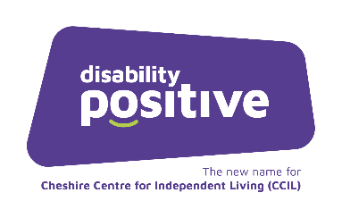

We now provide a General Advocacy service for people with lived experience of disability and long-term conditions of all ages, across Cheshire.

Our Advocates can support you with specific issues; including difficulties with things like housing, benefits appeals, education appeals, children’s welfare, and to support you to write letters and to attend meetings.

For Statutory Advocacy services including Care Act Advocacy, Independent Mental Capacity Advocacy (IMCA), or Independent Mental Health Advocacy (IMHA) please complete the relevant referral form or contact the Cheshire Advocacy Hub. (Tel: 03333660027)

Please complete all the requested information in order that we can process your referral.

Client Name
Email address:
Telephone number
Permanent Address and Postcode
Current location if different
Date of Birth
Gender
Registered GP:

Description of the issues
for example: support with difficulties with housing, benefits appeals, education, children’s welfare, and support with writing letters and attending meetings. Include any significant dates i.e. Court hearings/Tribunals:

Communication
Please tell us how you prefer to communicate?
☐English  ☐Other spoken language (please specify)  ☐British Sign Language  ☐Words/pictures/Makaton | ☐Gestures/facial expressions/ vocalisations  ☐No obvious means of communication  ☐Other (please state)

Nature of impairment? (Please tick at least one)
☐ Mental health problems  ☐ Cognitive impairment  ☐ Physical impairment  ☐ Learning disability  ☐ Acquired brain injury | ☐ Dementia  ☐ Autistic spectrum disorder  ☐ Unconsciousness  ☐ Other (please state)

Risk Factors
Is there anything at home or otherwise that the advocate needs to know to keep you and/or the Advocate safe (e.g. pets, health or behavioral issues?)

Details of referrer (if different to above)
Name
Contact Address:
Email:
Telephone:
Relationship to client:
Does the client have capacity to consent to the referral on their behalf?
Yes | ☐ | No | ☐
If no, are you making this referral in their best interests
Yes | ☐ | No | ☐

Consent
I have read and understood how you will use and process my data for this service and I have informed any relevant third-parties of the information I provide to you about them, in line with the privacy notice

Signed Date

Thank you

Please return your completed form to advocacy@disabilitypositive.org

