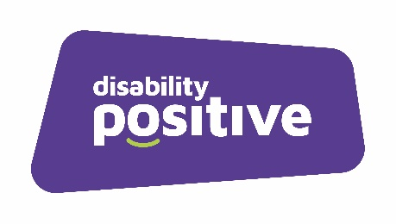
Disability Positive
In House Training Courses
2023-2024

PA Name: ……………………………… Email: …………………………………………………..
Employers Name: ….……….……….… Email: ……………………………………………….

Course: First Aid
Length: Full Day
Provider: Cherry Tree Training
Dates Available | Please TICK preferred date | Number of Places required
31.8.23
29.9.23
16.10.23
20.11.23
20.12.23
18.1.24
26.2.24
22.3.24

Course: Manual Handling
Length: Full Day Training
Provider: Abuka Training
Dates Available | Please TICK preferred date | Number of Places required
24.8.23
20.9.23
9.10.23
9.11.23
12.12.23
8.1.24
16.2.24
11.3.24

Course: Safeguarding
Length: Half Day Training
Provider: Sarah Freer
Dates Available | Please TICK preferred date | Number of Places required
26.10.23 (pm) *
24.10.23 (am) *
2.11.23 (am) *
14.11.23 (pm) *
7.12.23 (am) *
4.1.24 (pm) *
7.2.24 (am) *
5.3.24 (pm) *

*Half Day Courses: a.m. 10pm – 1pm ~ p.m. 12.30 – 4.30pm
Course: Makaton
Length: Full Day
Provider: Inclusive Teaching matters
Dates Available | Please TICK preferred date | Number of Places required
Date to be confirmed
6.11.23

Course: Good Employer Training
Length: Full Day
Provider: Abuka
Dates Available | Please TICK preferred date | Number of Places required
26 .9.23: On Line via Zoom
19.12.23
13.3.24
All courses are held at Disability Positive unless otherwise stated.

Address:  Sension House  Denton Drive  Northwich  Cheshire  CW9 7LU | Tele: 01606 331853  Email to: learning@disabilitypositive.org

